**CHAPTER 1**

**INTRODUCTION**

* 1. **PROJECT OVERVIEW**

The popular trend in today's technology driven world is ‘Cloud Computing’. Cloud computing can be referred to as the storing and accessing of data over the internet rather than your computer's hard drive. This means you don't access the data from either your computer's hard drive or over a dedicated computer network (home or office network). Cloud computing means data is stored at a remote place and is synchronized with other web information.

Cloud computing is an Information Technology (IT) paradigm that enables ubiquitous access to shared pools of configurable system resources and higher level services that can be rapidly provisioned with minimal management effort, often over the Internet. Cloud computing relies on sharing on resources to achieve coherence and economic of scale, similar to a utility over a network. Cloud computing, or in simpler short hand just “The cloud”, also focuses maximizing the effectiveness of the shared resources. Cloud resources are usually not only shared by multiple users but are also dynamically reallocated per demand. This approach should maximize the use of computing power thus reducing environmental damage as well since power less, air conditioning, rack space, etc., are required for variety of functions.

Third party clouds enable organizations to focus on their core businesses instead of expending resources on computer infrastructure and maintenance. Advocates note that cloud computing allows companies to avoid or minimize up-front IT infrastructure costs. Proponents also claim that cloud computing allows enterprises to get their applications up and running faster, with improved manageability and less maintenance and that it enables IT teams to more rapidly adjust resources to meet fluctuating and unpredictable demand. Cloud providers typically use a “pay-as-you-go” model, which can lead to unexpected operating expenses if administrators are not familiarized with cloud pricing models.

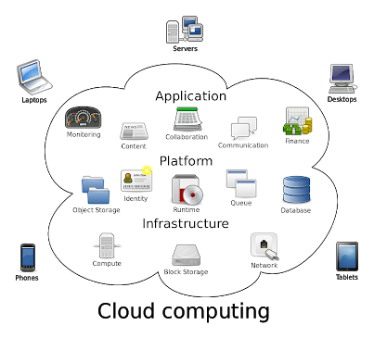

This information is accessible Nationwide with the Unique ID. This application makes the maintenance of record simple and handy. This System enables ease of access to the Users.

* 1. **AIM:**

E- PLACEMENT is a total management and informative system, which provides the up-to date information of all the students in a particular college.

**PROBLEM DEFINITION**

Now a day’s campus placements are conducted in all colleges. Various software and other sector companies are conducting campus selections for selecting merit candidates. When campus selections are conducted the students should provide their curriculum vitae to the concern officer for attending the campus interviews. This routine process is maintained manually, like maintenance of their resumes in papers. This can be automated by designing software.

* 1. **OBJECTIVE:**

E Placement helps the colleges to overcome the difficulty in keeping records of hundreds and thousands of students and searching for a student eligible for recruitment criteria from the whole thing. It helps in effective and timely utilization of the hardware and the software resources.

**CHAPTER 2**

**SYSTEM ANALYSIS**

System analysis is a problem solving technique that decomposes a system in to its component pieces for the purpose of studying how well those component parts work and interact to accomplish their purposes. System analysis is the process of studying a procedure or business in order to identify its goals and purposes and create systems and procedures that will achieve them in an efficient way. Analysis and synthesis, as a scientific methods, always go hand in hand; they complement one another. Every synthesis is built up on the results of a preceding analysis, and every analysis requires a subsequent synthesis in order to verify and correct its results.

* 1. **EXISTING SYSTEM**

The earlier system is not computerized. All transactions in the system are done manually maintaining records. To make this laborious job simple the clients have to computerize the system. The management and all the departments that have been carrying out this job using manually makes the job more complicated and tedious most of the times. So, the best way is computerize computerization of the current environment. For example, in the earlier system placement officer has to collect student details for placements. Approving those student details takes lot of time. Placement officer and students have to consult each other directly if any information is needed. If any new company come for placements, placement officer and his staff has to search the student details and they have to find the eligible candidates for that particular company placement. Here searching for eligible candidates takes lots of time. And sometimes some candidates’ details may be missed.

* + 1. **Drawbacks of Existing System**

1. It takes so much time for a placement officer to collect students’ details and approving the details provided by them.
2. Poor communication between students and placement officer, so here intimating about new placements is a hard task.
3. Students may not know about company details.
4. Here also poor communication provides a problem.
5. Candidate may not get required information if concerned TPO is not at the desk.
   1. **NEED FOR PROPOSED SYSTEM**

The proposed system is fully computerized, which removes all the drawbacks of existing system. Proposed system is an online application that can be accessed throughout the organization and outside as well with proper login provided. Students logging should be able to upload their information in the form of a CV. The administrator will create the users and the users will use the accounts created by administrator. When the user entered into his respective page he has to update his details. And the details are to be approved by the administrator. All the users have some common services like changing password, updating details, searching for details, checking the details, mailing to administrator, and reading the material uploaded by admin if the user is a student. Administrator has to do the services like adding events, achievements and he can reply to the mails sent by users. He can upload materials, search for student details, and he has the right to approve the students.

* 1. **FEATURES OF PROPOSED SYSTEM**

Placement officer can easily collect student’ details, and approve the details provided by them. As it is an online application, communication with placement officer is easy to students and recruiters, so here intimating about new placements very easy task. Here recruiters can also search for the details provided by students on the basis of their percentage. Placement officer can send required materials used for placements preparation to students. With this option preparation for placements becomes easy.

* + 1. **Feasibility Study**

The feasibility of the project is analyzed in this phase and business proposal is but forth with a very general plan for the project and some cost estimates. During system analysis the feasibility study of the proposed system is to be carried out. This is to ensure that the proposed system is not a burden to the company. For feasibility analysis, some understanding of the major requirements for the system is essential.

Three key considerations involved in the feasibility analysis are

1. Economical Feasibility

2. Technical Feasibility

3. Social Feasibility

**1. Economical Feasibility**

This study is carried out to check the economic impact that the system will have on the organization. The amount of found can company can pour into the research and development of the system is limited. The expenditures must be justified. Thus the development system as well within the budget and this was achieved because most of the technologies are freely available. Only the customized products had to be purchased.

**2. Technical Feasibility**

This study is carried out to check the technical feasibility, that is, the technical requirements of the system. Any system developed must not have a high demand on the available technical resources. This will lead to high demands being placed on the client. The developed system must have a modest requirement, as only minimal or null changes are required for implementing this system.

**3. Social Feasibility**

The aspect of study is to check the level of acceptance of the system by user. This includes the process of training the user to the system efficiently. The user must not feel the threatened by the system, instead must accept it as a necessity. The level of acceptance by the users solely depends on the methods are employed to educate the user about the system and to make him familiar with nit. His level of confidence must be raised but also able to make some constructive criticism, which is welcomed, as the final user of the system.

* 1. **REQUIREMENT ANALYSIS**

**2.4.1 HARDWARE REQUIREMENTS**

Processor : Pentium –I Core

RAM : 2 GB

Hard Disk : 1.28GB

* + 1. **SOFTWARE REQUIREMENTS**

Operating System : Windows 7/8/10

Front End : HTML, CSS and BOOTSTRAP

Script : JavaScript

Back End : PHP

Database : MYSQL

Cloud Service : Amazon Web Service

Tools : XAMPP

* + - 1. **TOOLS:**

**XAMPP** 

XAMPP stands for Cross-Platform (X), Apache (A), MySQL (M), PHP (P) and Perl (P). It is a simple, lightweight Apache distribution that makes it extremely easy for developers to create a local web server for testing purposes. ... XAMPP is also cross-platform, which means it works equally well on Linux, Mac and Windows. It is a simple, lightweight Apache distribution that makes it extremely easy for developers to create a local web server for testing and deployment purposes.

**2.4.2.2 PROGRAMING LANGUAGES:**

**JavaScript:**

JavaScript often abbreviated as JS, is a [high-level](https://en.wikipedia.org/wiki/High-level_programming_language), [interpreted](https://en.wikipedia.org/wiki/Interpreted_language) [programming language](https://en.wikipedia.org/wiki/Programming_language). It is a language which is also characterized as [dynamic](https://en.wikipedia.org/wiki/Dynamic_programming_language), [weakly typed](https://en.wikipedia.org/wiki/Weak_typing), [prototype-based](https://en.wikipedia.org/wiki/Prototype-based_programming) and [multi-paradigm](https://en.wikipedia.org/wiki/Multi-paradigm_programming_language). Alongside [HTML](https://en.wikipedia.org/wiki/HTML) and [CSS](https://en.wikipedia.org/wiki/CSS), JavaScript is one of the three core technologies of [World Wide Web](https://en.wikipedia.org/wiki/World_Wide_Web) [content engineering](https://en.wikipedia.org/wiki/Content_engineering). It is used to make dynamic Web pages interactive and provide online programs, including video games. The majority of [websites](https://en.wikipedia.org/wiki/Website) employ it, and all modern [web browsers](https://en.wikipedia.org/wiki/Web_browser) support it without the need for [plug-ins](https://en.wikipedia.org/wiki/Browser_extension) by means of a built-in [JavaScript engine](https://en.wikipedia.org/wiki/JavaScript_engine). Each of the many JavaScript engines represent a different implementation of JavaScript, all based on the [ECMA Script](https://en.wikipedia.org/wiki/ECMAScript) specification, with some engines not supporting the spec fully, and with many engines supporting additional features beyond ECMA.

**HTML:**

HTML(Hypertext Markup Language)is the set of markup symbols or codes inserted in a file intended for display on a World Web browser page. The markup tells the Web browser how to display a Web page’s words and images for the users. Each individual markup code is referred to as an element (but many people also refer to it as a tag). Some elements come in pairs that indicate when some display effect is to begin and when it is to end.

HTML markup consists of several key components, including those called tags(and their attributes), character-based data types, character references and entity references.HTML tags most commonly come in pairs like <h1> and </h1> although some represent empty elements and so are unpaired ,for example <img>.

The first tag in such a pair is the start tag, and the second is the end tag (they are also called opening and closing tags). Another important component is the HTML document style type declaration, which triggers standards mode rendering.

Hyper Text Markup Language, commonly referred to as HTML, is the standard markup language used to create web pages. Along with CSS and JavaScript, HTML is a cornerstone technology used to create web pages, as well as to create user interfaces for mobile and web applications.

**CSS:**

Cascading Style Sheets (CSS) is a style sheet language used for describing the presentation of a document written in a markup language. Although most often used to set the visual style of web pages and user interfaces written in HTML and XHTML, the language can be applied to any XML document, including plain XML, SVG and XUL, and is applicable to rendering in speech, or on other media. Along with HTML and JavaScript, CSS is a cornerstone technology used by most websites to create visually engaging Webpages, user interfaces for web applications, and user interfaces for many mobile applications.

CSS was first proposed by HåkonWium Lie on October 10, 1994. At the time, Lie was working with Tim Berners-Lee at CERN. Several other style sheet languages for the web were proposed around the same time, and discussions on public mailing lists and inside World Wide Web Consortium resulted in the first W3C CSS Recommendation (CSS1) being released in 1996. In particular, a proposal by Bert Bos was influential; he became co-author of CSS1, and is regarded as co-creator of CSS.

**PHP**

PHP is an acronym of Hypertext Pre-processor. PHP is a server-side scripting language designed for web development but also used as a general- purpose programming language. PHP code can be simply mixed with HTML code, or it can be used in combination with various tinplating engines and web frameworks. PHP code is usually processed by a PHP interpreter, which is usually implemented as a web server's native module or a COMMON GATEWAY INTERFACE (CGI) executable. After the PHP code is interpreted and executed, the web server sends resulting output to its client, usually in form of a part of the generated web page; for example, PHP code can generate a web page's HTML code, an image, or some other data. PHP has also evolved to include a COMMAND-LINE INTERFACE (CLI) capability and can be used in standalone graphical applications. PHP has been widely ported and can be deployed on most web servers on almost every operating system and platform, free of charge.

* + - 1. **DATABASE:**

**MySQL**

MySQL is an open-source relational database management system (RDBMS). Its name is combinations of “My”, the name of co-founder Michael Widenius's daughter, and "SQL", the abbreviation for Structured Query Language. The MySQL development project has made its source code available under the terms of the GNU General Public License, as well as under a variety of proprietary agreements. MySQL was owned and sponsored by a single for-profit firm, the Swedish company MySQL AB, now owned by Oracle Corporation. For proprietary use, several paid editions are available, and offer additional functionality.

**CHAPTER 3**

**SYSTEM DESIGN**

**3.1 UML DIAGRAMS**

The Unified Modelling Language is a standard language for specifying, visualizing, constructing, and documenting the artifacts of the software systems, as well as for business modelling and other non-software systems. The UML represents a collection of the best engineering practices that have proven successful in modelling of large and complex systems.

**3.1.1 Use Case Diagram**

A use case is a set of scenarios that describing an interaction between a user and system. A use case diagram displays the relationship among the actors and use cases. The two main components of a use case diagram are use cases and actors. Here figure 3.1 describes the use case diagram for providing user file security which deals with actor such as admin and users.

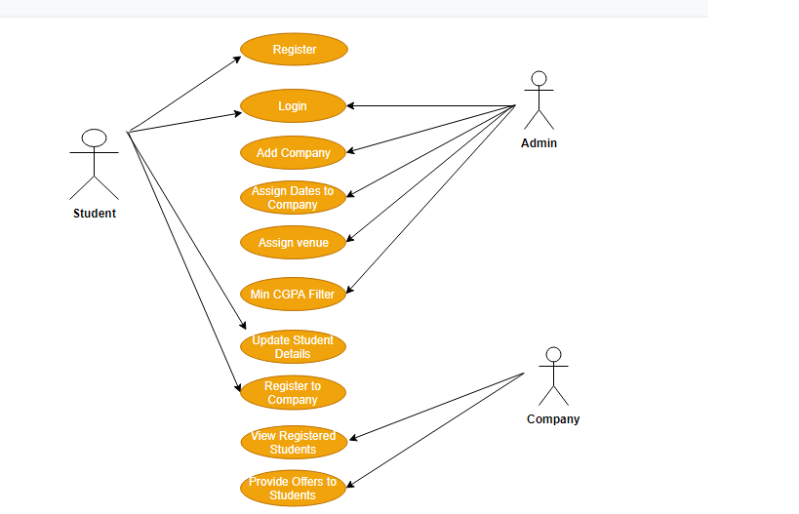

**Figure 3.1 Use case diagram**

**3.1.2 Class Diagram**

Class diagrams are the most common diagrams used in UML. Class diagram consists of classes, interfaces, associations and collaborations. Class diagrams are basically represent the object oriented view of the system which is static in nature. Active class is used in the class diagram to represent the concurrency of the system. This is the most widely used diagram at the time of system construction. In figure 3.2 describes the class diagram for register class, login class, upload file class, download file class and encryption class.

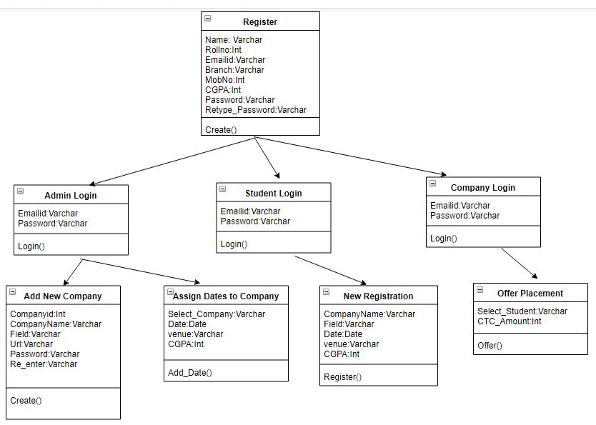

**Figure 3.2 Class diagram**

**3.1.3 Sequence Diagram**

A sequence diagram is an interaction diagram. Sequence diagram is used to visualize the sequence of calls in a system to perform a specific functionality. In figure 3.3 represents the sequence of steps happened between user, admin, database (DB) and cloud storage.

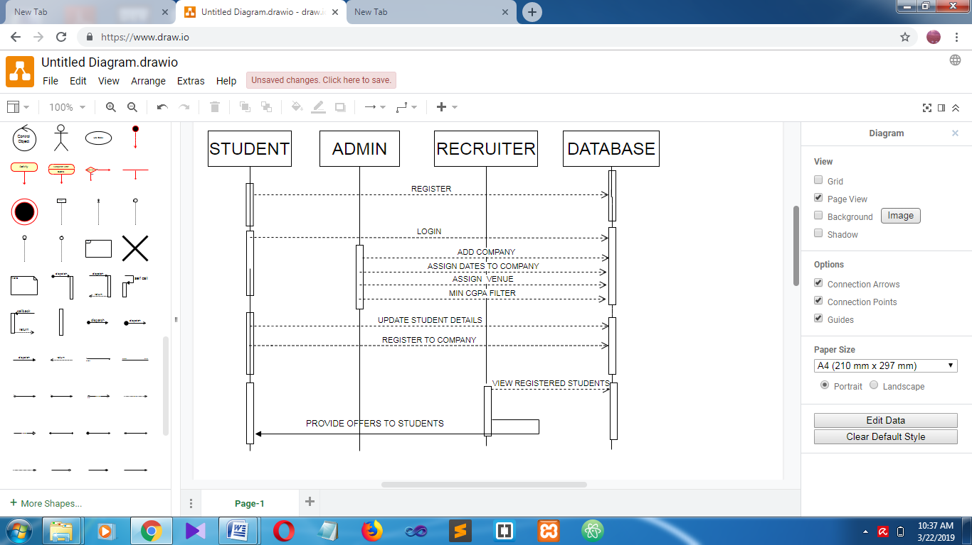

**Figure 3.3 Sequence diagram**

**3.1.4 Activity Diagram**

Activity diagram is another important diagram in UML to describe dynamic aspects of the system. This diagram is basically a flow chart to represent the flow from one activity to another activity. The basic purposes of activity diagrams are similar to other four diagrams. It captures the dynamic behavior of the system. Activity is the particular operation of the system. Figure 3.4 denotes the activities that are performed by the user for providing file security in cloud infrastructure.

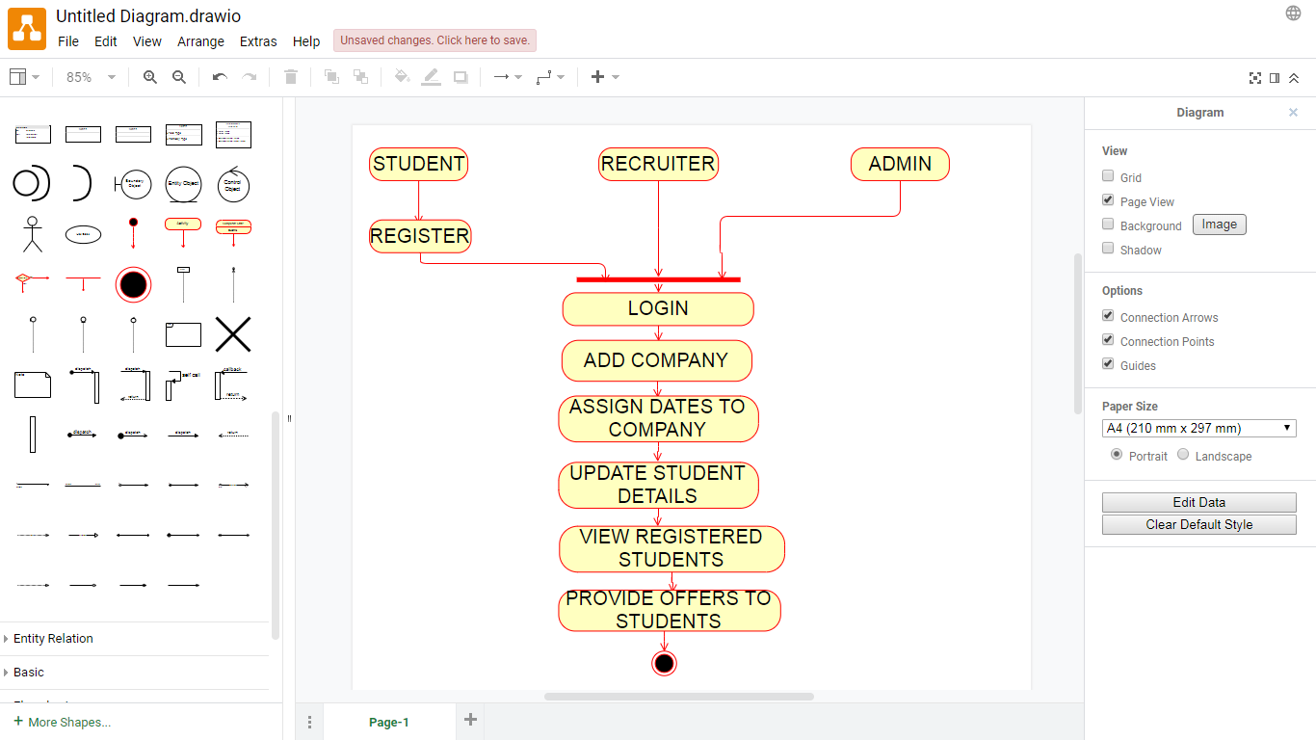

**Figure 3.4 Activity diagram**

**3.1.5 ER Diagram**

An entity–relationship model (ER model for short) describes interrelated things of interest in a specific domain of knowledge. A basic ER model is composed of entity types (which classify the things of interest) and specifies relationships that can exist between instances of those entity types. An ER model for the project is described in this figure 3.5 which consist of all entities with their relationships. 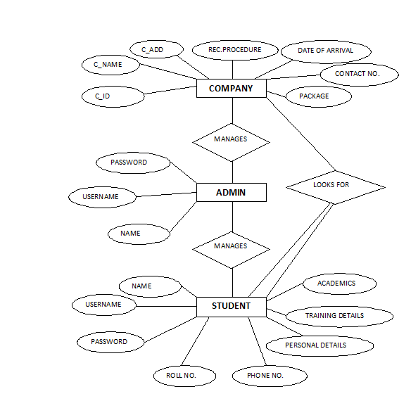

**Figure 3.5 ER diagram**

* + 1. **System Architecture Diagram**

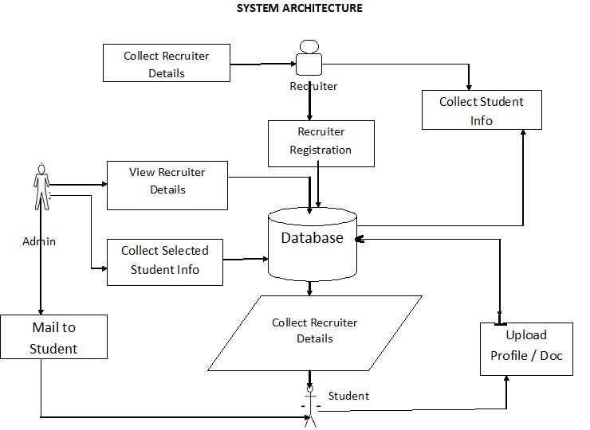This diagram represents the overall structure of the system. It also shows the behavior of the system in an abstracted way. The System architecture diagram for Student placement system which clearly describes the process of how the user and admin interacts with cloud database is shown in figure 3.6.

**Figure 3.6 System architecture diagram**

* 1. **DATABASE DESIGN:**

**3.2.1 USER REGISTRATION**

|  |  |  |
| --- | --- | --- |
| **S.NO.** | **FIELDS** | **DATATYPE** |
| 1 | NAME | STRING |
| 2 | ROLL NO | STRING |
| 3 | EMAIL-ID | STRING |
| 4 | CONTACTNO | STRING |
| 5 | BRANCH | STRING |
| 6 | C.G.P.A | FLAOT |
| 7 | PASSING YEAR | INT |
| 8 | PASSWORD | CHAR |

**3.2.2 COMPANY REGISTRATION:**

|  |  |  |
| --- | --- | --- |
| **S.NO.** | **FIELDS** | **DATATYPE** |
| 1 | COMAPNY ID | STRING |
| 2 | COMPANY NAME | STRING |
| 3 | FIELD | STRING |
| 4 | URL | VARCHAR |
| 5 | PASSWORD | CHAR |

**3.2.3 ADMIN DATA:**

|  |  |  |
| --- | --- | --- |
| **S.NO.** | **FIELDS** | **DATATYPE** |
| 1 | USERNAME | STRING |
| 2 | PASSWORD | CHAR |

**CHAPTER 4**

**IMPLEMENTATION AND TESTING**

**4.1 MODULE DESCRIPTION**

There are mainly **3** modules in the project “**Training and Placement Cell**“

They are:

* Student module.
* Administrator module.
* Recruiter module.

**4.1.1 STUDENT MODULE:**

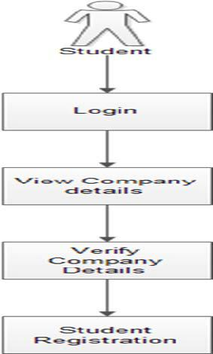

**Figure 4.1.1 Overview of Student Module**

In this module, creation of student input records about academic career from SSLC, HSC and all semester with facilities to modify the records and viewing changed records. The Student views the company details and verifies particular company details and provides valid details for registration.

* **Update details:** This service provides the user to update their details.
* **Check details:** This service provides the user to check his details.
* **Material:** This service provides the user to check for materials uploaded by administrator

**SCREENSHOT OF STUDENT’S REGISTRATION MODULE:**

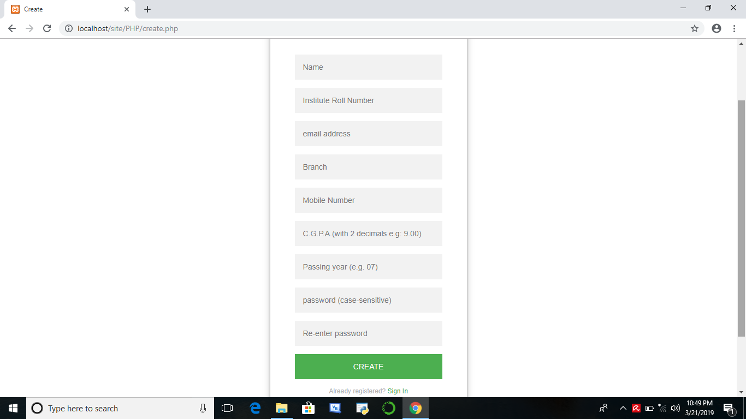

1. **Registration page of Student**

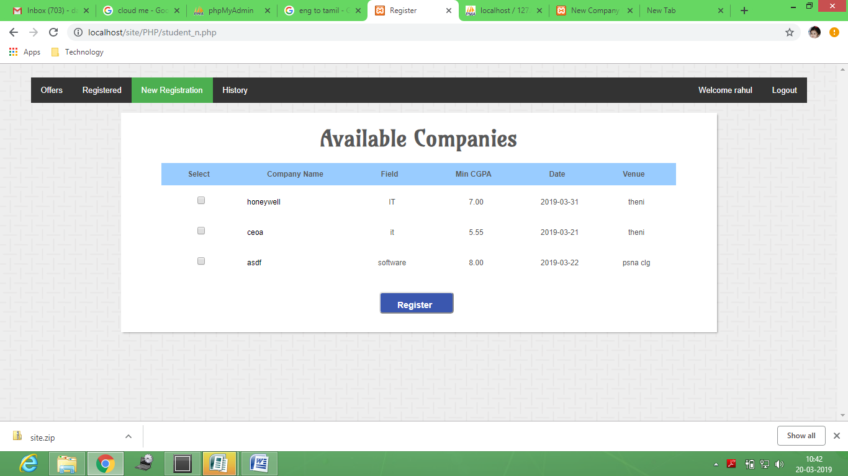

1. **Screenshot of Available companies.**

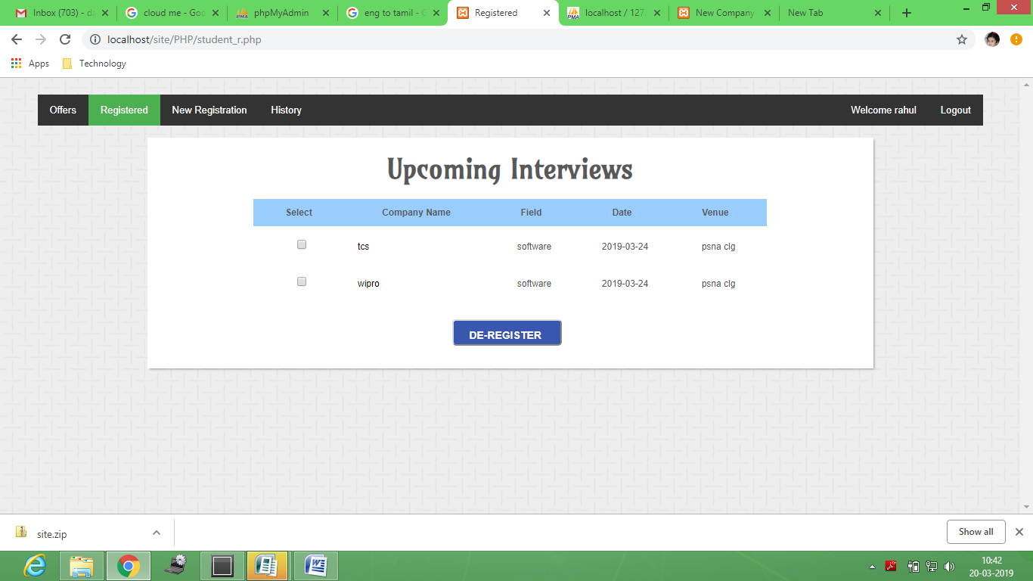

**3. Screenshot of Upcoming Interviews.**

**4.1.2 ADMINISTRATOR MODULE:**

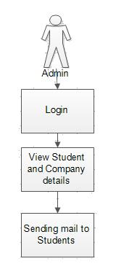

**Figure 4.1.2 Overview of Admin Module**

The admin is the placement officer who views the students details and company details and post the selected students list. Sending email to student for complete list of information for particular campus. Indication of hall ticket issued to candidates through mail. Login, View company details, View selected students details, Sending mail.

* **Update details:** Allows administrator to update his (college) details.
* **Update statistics:** Allows administrator to insert/update statistics like no. Of students selected etc.
* **Add student:** Allows administrator to add a student to database.
* **Add recruiter:** Allows administrator to add a recruiter to database.
* **Add event:** Allows administrator to add/insert an event.
* **Approve:** Allows administrator to verify the details of the student, and to Approve him to the application if they are correct.
* **Student details:** Allows administrator to search for student information According to eligibility criteria for recruitment process.
* **Change password:** This service enables the administrator to change password.

**SCREENSHOTS OF ADMIN MODULE:**

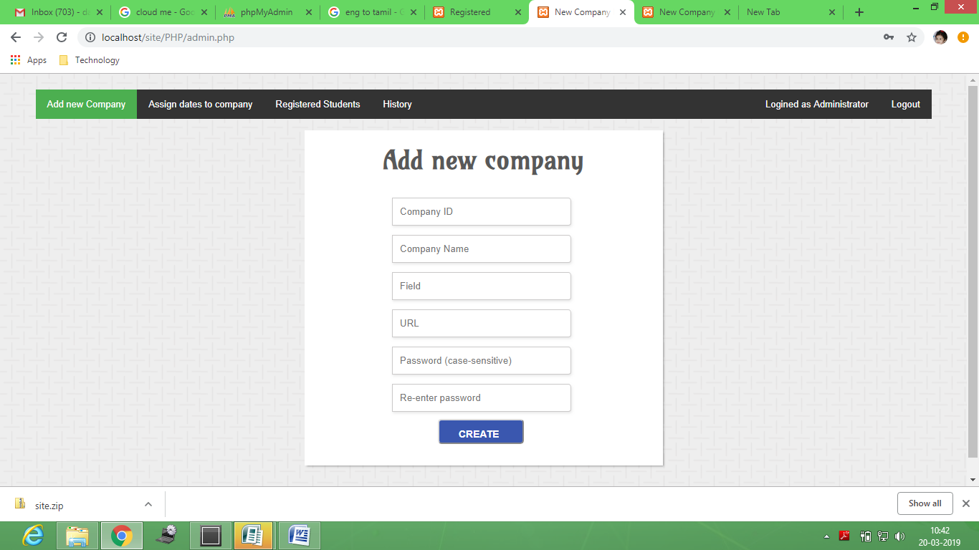

**1. Screenshot of Add new company**

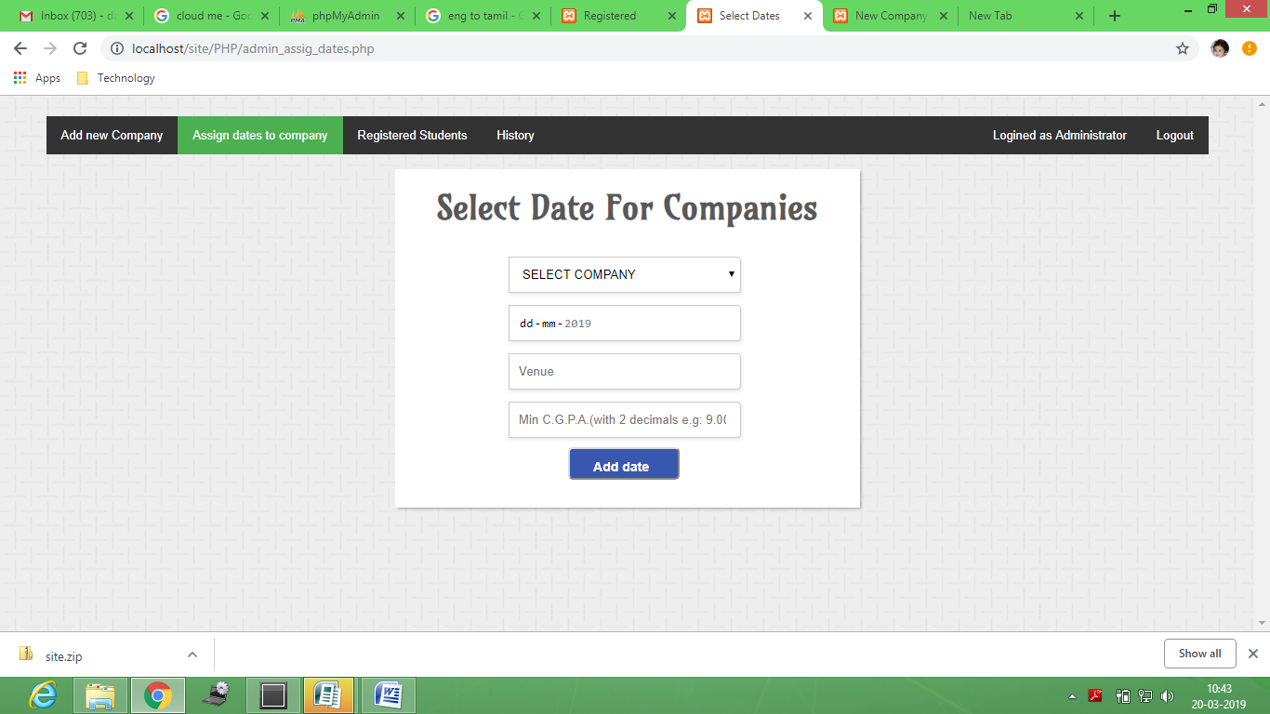

**2. Screenshots of date selection**

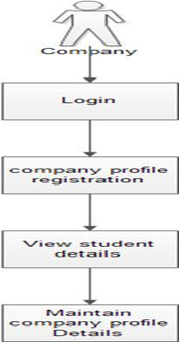**4.1.3 COMPANY MODULE:**

**Figure 4.1.3 Overview of Company Module**

The company enrolls themselves and they register their profile and their will marquee in the main page till their drive and view the student’s details and update their details.

**SCREENSHOTS OF COMPANY MODULE:-**

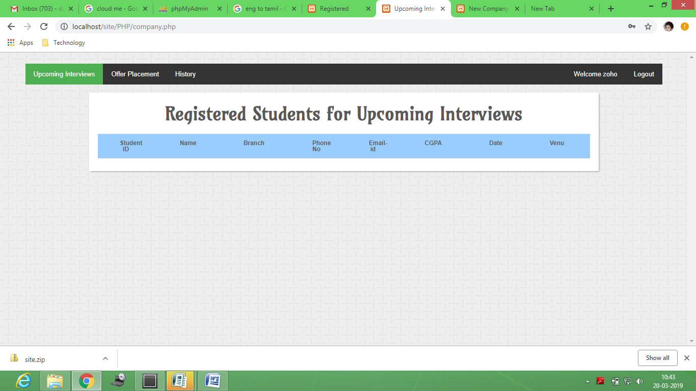

1. **Screenshot of Registered students for upcoming interviews.**

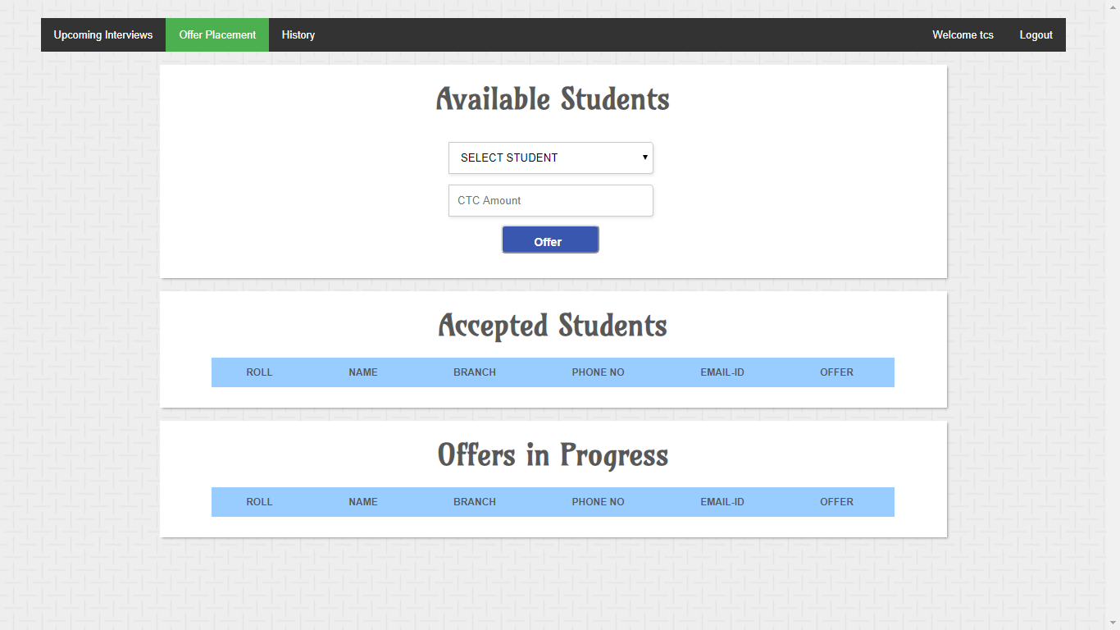

1. **Screenshots of offers in progress**

**4.2 TESTING**

Since the error in the software can be injured at any stage. So, we have carry out the testing process at different levels during the development. The basic levels of testing are,

* Unit Testing
* Integration Testing
* Validation Testing
* Functional Testing
* Structural Testing

**4.2.1 Unit Testing**

Unit testing was used to test individual units in the system and ensure that they operate correctly. Alternate logic analysis and screen validations were tested in this to ensure optimum efficiency in the system. The procedures and functions used and their association with data were tested.

* + 1. **Integration Testing**

This testing process focuses on identifying the interfaces between components and their functionality. The bottom up approach was adopted during this testing. Low-level modules are integrated and combined as a cluster before testing. This allowed identifying any wrong linkages or parameters passing early in the development process as it just can be passed in the set of data and checked if the result returned is an accepted one.

* + 1. **Validation Testing**

Software testing and validation is achieved through a series of block box tests that demonstrate conformity with requirements. A test procedure defines specific test cases that will be used to demonstrate conformity with requirements. Both, the plan and the procedure are designed to ensure that all functional requirements are achieved, documentation is correct and other requirements are met. After each validation test case has been conducted, one of the two possible conditions exists.

* + 1. **Functional Testing**

Functional testing, also known as block box or closed box testing, is normally applied to HDL (High-Level Data Link) code that operates concurrently and concentrates on checking the interaction between modules, blocks or functional boundaries. The objective here is to ensure that `correct results” are obtained when `good inputs” are applied operates in a predictable manner. Functional testing can therefore be considered as concentrating on checking that the data paths operate correctly. The coverage measurements that fall into this category are toggle, triggering, and signal trace coverage.

* + 1. **Structural Testing**

Structural testing, are known as white box or open box testing, is normally applied to sequential HDL (High-Level Data Link) code and concentrates on checking that all executable statements within each module have been exercised and the corresponding branches and paths through that module have been covered. If there is a section of HDL code that has never been exercised then there is a high possibility that it could contain an error that will remain undetected.

* 1. **DRIVING TEST CASES**

A test case is a set of conditions or variables under which a tester will determine if a requirement upon an application is partially or fully satisfied. The types of testing that are to be carried out on the system is as follows.

|  |  |  |  |  |
| --- | --- | --- | --- | --- |
| **Test case no** | **Description** | **Pre-conditions** | **Pass/Fail** | **Expected results** |
| SPS_001 | Validate user Registration | New user only allowed | Pass | Registered Successfully |
| SPS _002 | Validate user login | Registered user only allowed | Pass | Login successfully |
| SPS _003 | Admin filter based on CGPA | Admin only allowed | Pass | Filter successfully |
| SPS _004 | Admin add company details | Admin only allowed | pass | Added successfully |
| SPS _005 | Student register/ Deregister | Eligible student are allowed | Pass | Applied Successfully |
| SPS _006 | Admin Assign date for Company recruitment. | Date assigned | Pass | Date assigned Successfully |
| SPS _007 | view registered student profiles | Registered company only allowed | Pass | Viewed Successfully |
| SPS _008 | Company select eligible student | Registered company only allowed | Pass | Offer received successfully |

**CHAPTER 5**

**CONCLUSION AND FUTURE WORK**

* 1. **CONCLUSION**

This project has emphasised the diversity of the sector and also the unique contribution it makes to student education and training. Perception and practice in the provision of student placements is also diverse and follows no recognisable pattern. Attitudes, documentation and relationships are not related to the size or scope of a particular organization. A positive attitude is not necessarily an indicator of integrated structures to support neither student placements nor engagement in student placement related activities.

The long-term goal of this project is to support the sector to contribute to the development of a skilled mental health workforce. Although student placements are seen as a positive strategy in the recruitment of new staff, there is no evidence that student placements in this sector result in employment in the agency or in the mental health sector. There is no evidence that agencies review or collect any information about the impact of student placements on the organisation.

The need to build an evidence base to support the activities related to and the benefits of student placements in this sector should be seen as a priority. Lack of promotion of the sector to education providers, students and other health service agencies and limited formal partnership arrangements causes many services to be isolated from participation in student placement activities. This severely inhibits the development of effective student placement management structures.

**5.2 FUTURE WORK**

The application developed is simple prototype to explain the basic functionalities of the upcoming application. In the upcoming release following features will be added

* Conducting mock tests is to be added.
* Emailing to eligible student is to be added.
* In proposed online placement system there is scope for improvement of the system. System is not providing the SMS integration. Hence, it can be modified to give the SMS integration.
* Apart from these there is scope for generating many more features.
* In the future we can place the system on the cloud so the maintenance of the data can be reduced.
* The Exam system will integrate with the online placement system so the student result can get directly. There can be many more future Enhancement & improvement in the Online Placement System.

**REFERENCES**

1. NileshRathod, Seema Shah, KavitaShirsat,”An Interactive Online Training & Placement System”, International Journal of Advanced Research in Computer and Communication Engineering, Vol. 3, Issue 12,December-2013.
2. Hitesh Kasture, SumitSaraiyya, AbhishekMalviya, PreetiBhagat,“Training & Placement Web Portal”, International Journal on Recent and Innovation Trends in Computing and Communication ISSN: 2321- 8169 Volume: 2 Issue: 3,March-2014.
3. Roger S Pressman, “Software Engineering – A Practitioner’s approach” McGraw – Hill International Editions, Fifth Edition, 2001.
4. Prof. AnaghaKulkarni , PriyankaHajare, PriyankaKhandave , ShitalAdhav,SwatiPimpale,“ Implementation of Online Placement System”, IJERMT All Rights Reserved International Journal of Emerging Research in Management &Technology ISSN: 2278 -9359 (Volume-5, Issue-1), January2016.
5. Mr R J LAIRD,“ Interactive Web-based Placement Management–Principles and Practice using OPUS”, School of Eng
6. Gaurav Chheda, Niket Gajra, Manal Chhaya, Jitesh Deshpande, Saylee Gharge, ”STUDENT PLACEMENT SYSTEM”, International Journal of Soft Computing and Engineering (IJSCE) ISSN: 2231-2307, Volume-1, Issue-6, January 2012.
7. Juan Zambada, Ricardo Quintero, Ramon Isijara, Ricardo Galeana, Luis Santillan, “An IoT based scholar bus monitoring system”, Smart Cities Conference (ISC2), 2015 IEEE First International, IEEE Xplore: 28 December 2015, DOI: 10.1109/ISC2.2015.7366202 .
8. Lin Kang, Stefan Poslad, Weidong Wang, Xiuhua Li, Yinghai Zhang, Chaowei Wang, “WEB PLACEMENT SYSTEM”, Intelligent Environment (IE), 2016 12th International conference, IEEE Xplore : 27 October 2010, DOI: 10.1109/IE.2016.
9. Nomusa Dlodlo, “The internet of things in placement and training in South Africa”, Emerging Trends in Networks and Computer Communications (ETNCC), 2015 International Conference, IEEE Xplore: 13 August 2015, DOI: 10.1109/ETNCC.2015.7184802.
10. Swati Choudhary, Monica Landge, ShitalSalunke, SwarupataSutar, KirtiMhamunkar-“Advance Training and placement web portal” International Journal of Technical Research and Application ISSN: 2320- 8163 Volume:4 Issue: 2,March-April 2016.

**URL**

1. Source :https://www.tutorialspoint.com
2. Source :https://www.javatpoints.com
3. Source :http://www.di-mgt.com.au/rsa_alg.html
4. Source :https://www.ionicframework.com/docs
5. Source :https://www.firebase.com/docs